Demonstrative Determiners

🔹 What Are Demonstrative Determiners?
# Source: AI Source: Provided by: [Data Path: Persons Table -> ID Column: 1, Name_En Column: Motasem Essam] -> From: [Chatgpt (GPT-4-turbo)] on [7/28/2025]
Demonstrative determiners (also called demonstrative adjectives) are used before nouns to point out specific people or things.
They indicate distance (near or far) and number (singular or plural).

✅ List of Demonstrative Determiners
# Source: AI Source: Provided by: [Data Path: Persons Table -> ID Column: 1, Name_En Column: Motasem Essam] -> From: [Chatgpt (GPT-4-turbo)] on [7/28/2025]
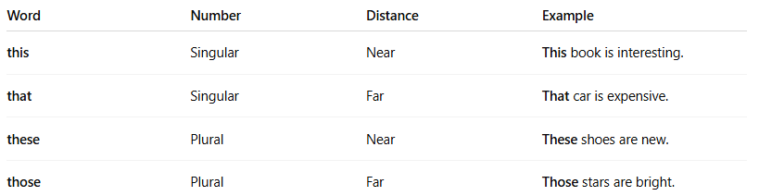
Word | Number | Distance | Example
this | Singular | Near | This book is interesting.
that | Singular | Far | That car is expensive.
these | Plural | Near | These shoes are new.
those | Plural | Far | Those stars are bright.

📚 Usage Notes
# Source: AI Source: Provided by: [Data Path: Persons Table -> ID Column: 1, Name_En Column: Motasem Essam] -> From: [Chatgpt (GPT-4-turbo)] on [7/28/2025]
- This / These → refer to things close to the speaker.
- That / Those → refer to things far from the speaker.
- Always placed before a noun (unlike demonstrative pronouns, which stand alone).

🔁 Comparison with Demonstrative Pronouns
# Source: AI Source: Provided by: [Data Path: Persons Table -> ID Column: 1, Name_En Column: Motasem Essam] -> From: [Chatgpt (GPT-4-turbo)] on [7/28/2025]
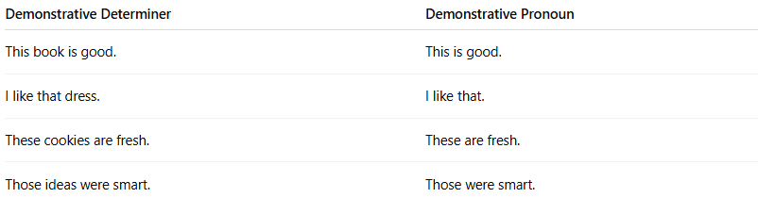
Demonstrative Determiner | Demonstrative Pronoun
This book is good. | This is good.
I like that dress. | I like that.
These cookies are fresh. | These are fresh.
Those ideas were smart. | Those were smart.

Demonstrative determiners and demonstrative adjectives are same thing ?
# Source: AI Source: Provided by: [Data Path: Persons Table -> ID Column: 1, Name_En Column: Motasem Essam] -> From: [Chatgpt (GPT-4-turbo)] on [7/28/2025]
Yes — Demonstrative determiners and demonstrative adjectives are the same thing in modern grammar, but used in slightly different contexts or terminology styles:

✅ They Refer to the Same Words:
# Source: AI Source: Provided by: [Data Path: Persons Table -> ID Column: 1, Name_En Column: Motasem Essam] -> From: [Chatgpt (GPT-4-turbo)] on [7/28/2025]
- this
- that
- these
- those

✅ Why Two Names?
# Source: AI Source: Provided by: [Data Path: Persons Table -> ID Column: 1, Name_En Column: Motasem Essam] -> From: [Chatgpt (GPT-4-turbo)] on [7/28/2025]
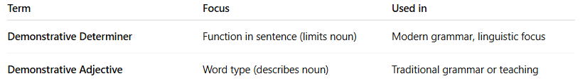
Term | Focus | Used in
Demonstrative Determiner | Function in sentence (limits noun) | Modern grammar, linguistic focus
Demonstrative Adjective | Word type (describes noun) | Traditional grammar or teaching

✅ Example (Same Function):
# Source: AI Source: Provided by: [Data Path: Persons Table -> ID Column: 1, Name_En Column: Motasem Essam] -> From: [Chatgpt (GPT-4-turbo)] on [7/28/2025]
- This book is interesting.
  - "This" is called a determiner (modern)
  - Or a demonstrative adjective (traditional)
In both, it modifies the noun "book", showing which book.

🔁 Summary:
# Source: AI Source: Provided by: [Data Path: Persons Table -> ID Column: 1, Name_En Column: Motasem Essam] -> From: [Chatgpt (GPT-4-turbo)] on [7/28/2025]
- ✅ Same words
- ✅ Same role (point out specific nouns)
- ❗Different terminology style:
  - Determiner = modern classification (based on function)
  - Adjective = traditional view (based on form)

